Set up a VPC with an Internet gateway, create a public subnet with 256 IP addresses, a private subnet with 256 IP addresses, make a route table connecting the Internet gateway and the subnets, and launch a Linux EC2 instance by using the above VPC and public subnet.

- CREATE A VPC :
- Navigate to the amazon VPC Console
- Choose our vpc and then create vpc
- Provide a name of our vpc (eg. Mycustomvpc)
- Specify an ipv4 cidr block which provides 256 usable ip address
- Choose “create vpc”.

- CREATE AN INTERNET GATEWAY & ATTACH IT TO THE VPC:

- In the vpc console choose internet gateways
- Choose create internet gateway
- Give it name (mycustomvpc)
- Choose “ create internet gateway”
- Select the newly created internet gateway choose action & then attach to vpc
- Select mycustomvpc & attach internet gateway
- CREATE PUBLIC & PRIVATE SUBNETS:
- In the vpc console choose subnets
- Choose create subnet
- Select mycustomvpc
- For the public subnet
- Name it (mypublicsubnet)
- Choose an availability zone

- Select an ipv4 cidr block ( eg: 10.0.0.0/25 for 128 usables ips) if you need 256 ips you would need to use a /24 cidr block for the subnet and allocate the entire vpc cidr block to this single subnet for two subnet of 256 ips each within a vpc the vpc would require a large cidr block like /23 assuming the request implies 256 addresses within the subnet, and not 256 usable addresses after aws reserves some a /24 cidr block for each subnet is necessage requiring a /23 vpc.

- FOR THE PRIVATE SUBNET :

- Name it (myprivate subnet)
- Choose an different availability zone for high availability
- Select an ipv4 cidr block (10.0.0.128/25)
- Choose create subnet.

- CONFIGURE ROUTE TABLES :

- In the vpc console choose route tables
- For the public route tables
- Select the route table automatically created with our vpc name it mypublic subnet
- Choose routes then edit routes
- Add a route : destination 0.0.0./0. target mycustomigw
- Choose save changes
- Choose subnet associations then edit subnet associations
- Select mypublicsubnet and save associations

- For the private route table:
- Creat a new route table name it myprivatesubnet
- Choose subnet associations then edit subnet associations
- Select myprivatesubnet and save associations (this route table will have only the local route within the vpc by default
- LAUNCH A LINUX EC2 INSTANCES IN THE PUBLIC SUBNET:

- Navigate to the amazon ec2 console
- Choose launch instances
- Provide a name for the instances
- Choose a linux amazon machine image
- Choose an instance type

- In network settings :
- Select mycustomvpc for the vpc
- Select mypublicsubnet for the subnet
- Enable autosign public ip
- Create or select a security group that allows ssh access (port 22) from your ip or 0.0.0/0 for testing
- Create or select a key pair
- Choose launch instances.

VPC INTERNET GATEWAY:

An internet gateway is a horizontally scaled redunant and highly available vpc component that allows communications between your vpc and the internet it supports ipv4 and ipv6 traffic. It does not cause availability risks or bandwidth constraints on your network traffic.

PUBLIC SUBNET:

A public subnet is a network segment has a direct route to the internet allowing resources within it to send and receive traffic directly from the public internet .

This achieved by the associating the subnet with a route table that include route to an internet gateway. Public subnet are typically used for resources that need to accessible from the internet, such as web servers,

CHARACTERISTICS OF PUBLIC SUBNET:

- INTERNET ACCESS :

Resources ina public subnet can be initiate outbound connections to the internet and can be reached directly from the internet

- ROUTING :
The defining feature is in route table which must have a direct route to an internet gateway for both inbound and outbound traffic to work

- RESOURCE PLACEMENT :

Its appropriate place for public facing resource like web servers load balancers or other services that user needs to access from outside the private network

- PUBLIC IP ASSIGNMENT:
Instances created in a public subnet can be assigned a public ip address to be reachable over the internet

Step 1: Create an Aws ec2 instance in a public subnet of any AWS region.

Select an AWS Ami (Amazon Machine image) like this :

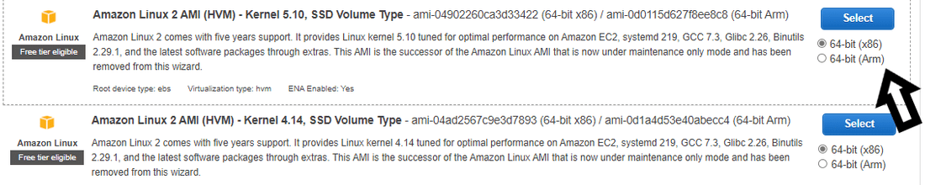

Then select an instance type for your ec2 instance. Instance types are the hardware that we need to launch an AWS ec2 instance like how much memory and number of CPUs you require in your instance.

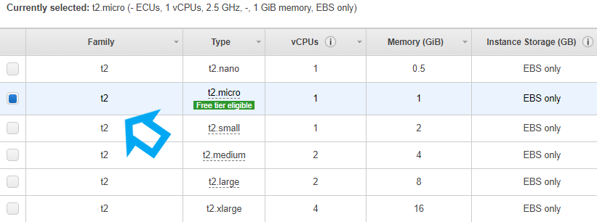

Now Configure the instance details and keep all other options as default. Now just select a subnet in any of the availability zones which is nearer to us in order to avoid any chance of latency.

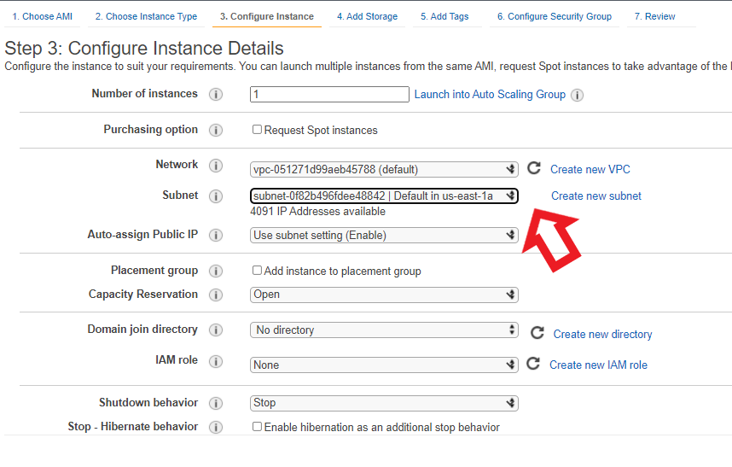

Now we have to add storage to our ec2 instance like this:

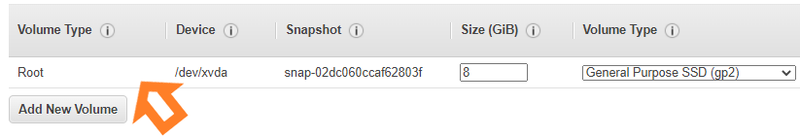

Now we can add a friendly name to your ec2 instance with the help of tags

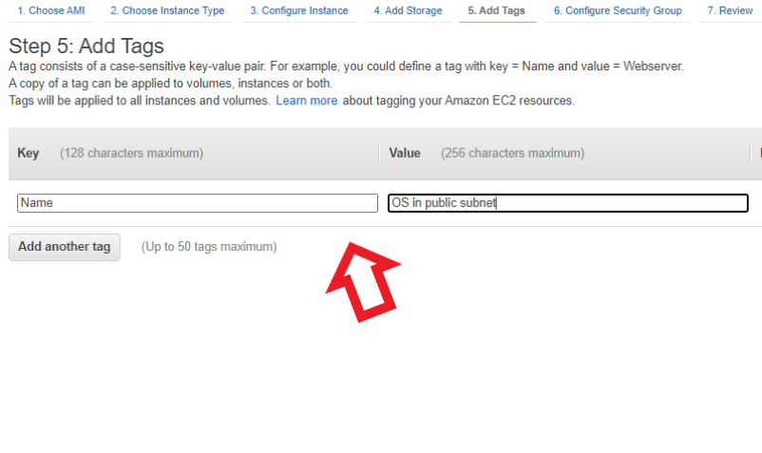

Now we have to configure a security group for our ec2 instance which is a set of rules that control the traffic coming to our instance.

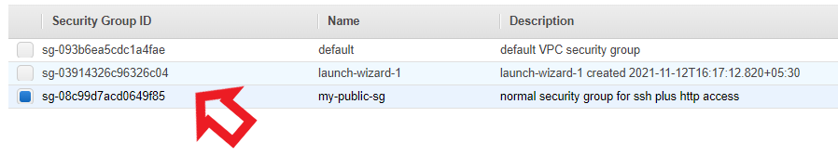

After this, we may have a final review of our instance. We can check the security group, instance details, storage, and tags of the instance. After making the final review of our instance click on launch. On clicking the launch button it will prompt us for selecting a key pair.

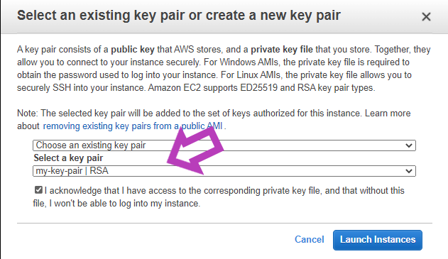

After selecting the key pair we may click on launch instances and ou instance will be launched.

Step 2: Create a private subnet in the same availability zone where we have launched our instance in the public subnet.

To create a subnet click on the Services and then click on VPC on clicking VPC will open up a VPC dashboard for you there you will find an option of subnets just click on it and here you can create your subnets.

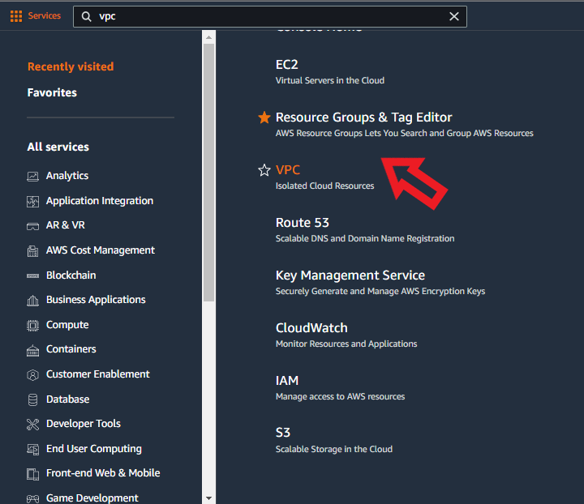

To create a private subnet here I will be using my already created private subnet or you can just create a new private subnet by clicking on Create subnet so the workflow will be like this:

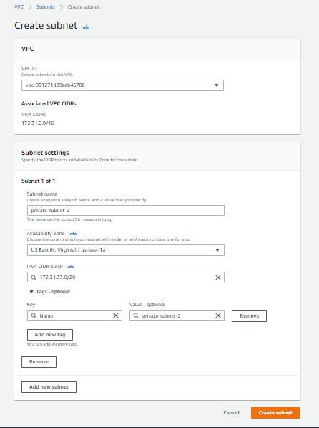

Now launch an ec2 instance the procedure is the same which I have written in step 1 for launching an ec2 instance the difference is only in the subnet you have to select your private subnet, not the default public subnet.

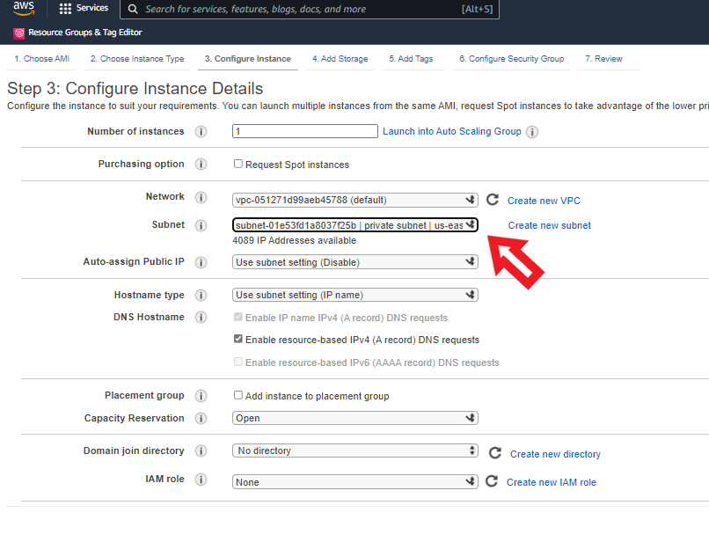

Step3: After that, we need to attach a route table to our private subnet which does not allow any IP address from outside for that we need to create a route Table and then associate that route table with the private subnet by just clicking on edit subnet association. Here I have already created the route table and associated it with the private subnet. But let me show you the steps for associating the route table to the subnet.

Create a route table:

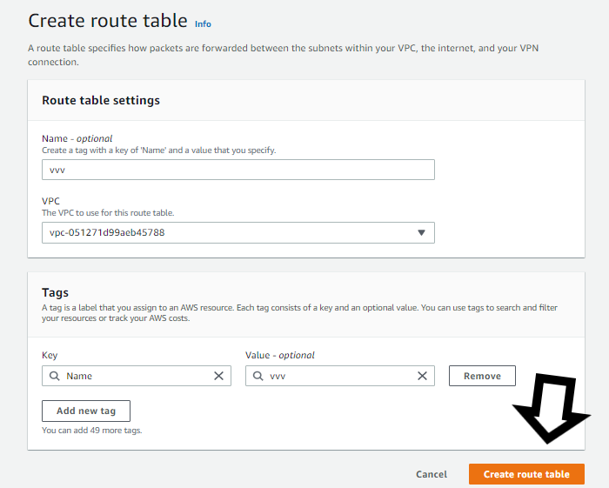

Associating the route table with subnet:

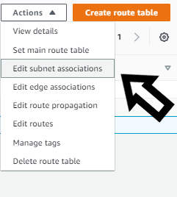

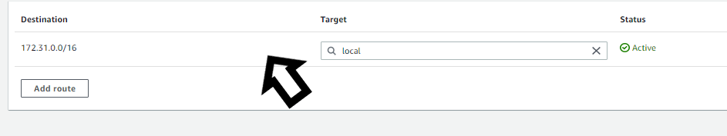

After that, you need to select your private subnet and then associate that subnet with the Route table so now no one from outside i.e internet can communicate with our instance in a private subnet only instances within the VPC in public and private subnets will have the possibility to communicate with each other.

Step 4: Now we will be using a tool called pageant
Open pageant and click on view keys then the pageant will be opened and there click the add key to add the key which we used for launching instances.
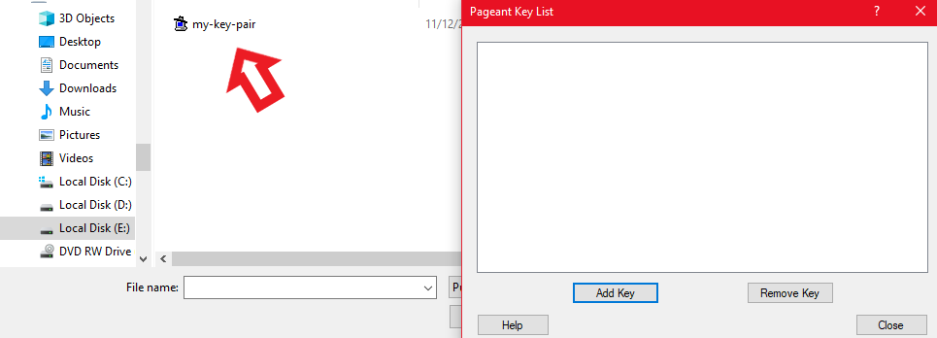

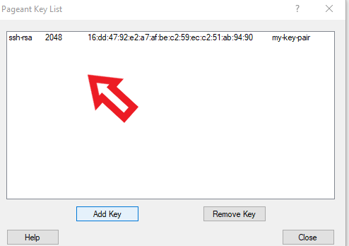

Step5: Now we will be using putty to connect instances

Open putty and type in the hostname of your instance in the public subnet and enable agent forwarding on putty.
Format for writing Hostname: username@public_ip_address_of_your_instance also you can just write public IP in the hostname and then connect but then it will ask for your username on login so to avoid that you can use the above format.
For writing hostname click on the Session option present in the putty window and there you will see an option for writing the hostname so just type in your hostname there.
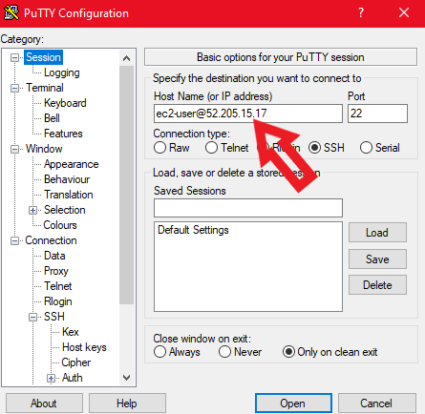
Click on SSH and then click on Auth and tick the option allow agent forwarding:
Click on SSH and then click on Auth and tick the option allow agent forwarding:

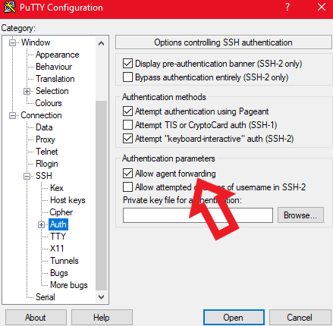

Step 6: Connecting an EC2 instance present in the private subnet using a bastion host
Now click on the open button as we have written the hostname and enabled the agent forwarding.
After this, you will be connected to your bastion host.
There use this command ssh user-name@ip_address_of_your_private_instance and you will be connected to your private ec2 instance.

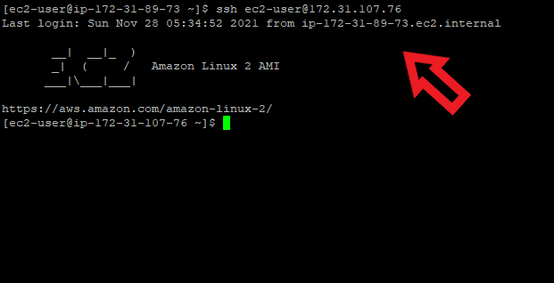

Setting up AWS Site-to-Site VPN Connection
The following are the steps that guides you on how to do AWS Site-to-Site VPN Connection:
Step 1: Log in to your AWS account > Choose a region (Here I have chosen the Mumbai region) >In the console page search for as follows,
VPC > Go to VPC page > Click on create VPC > Click on VPC only > Give a name to your VPC(name-vpc-aws), IPv4 CIDR range.
Here we have given 10.100.0.0/16), Tenancy-default > Click on create VPC.
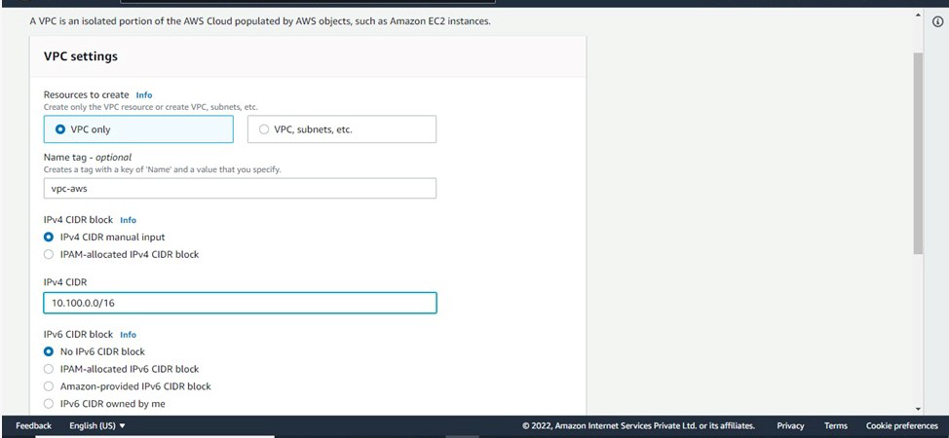

Step 2: Create a Private subnet under it-
For that search, subnet > Click on create subnet > Fill in the details (Choose above created VPC, give a Name, Availability zone, CIDR range-10.100.0.0/24) > Click on create a subnet.
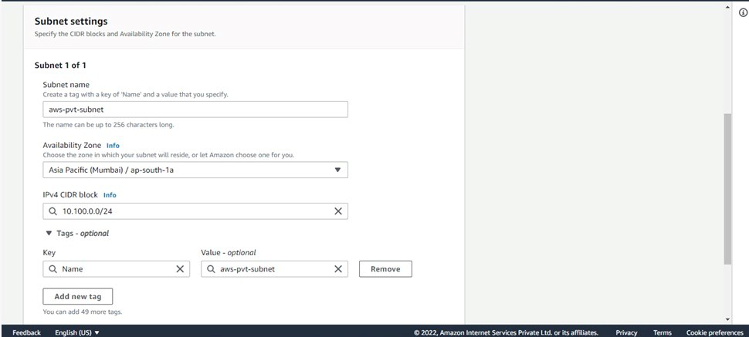

Step 3: Go to route table > Click on create route > Fill in the details(Give it name and choose VPC created on step-1) > Click on create.
Step 4: Associate route table with the subnet- Select Route table > Subnet Associations > Edit Subnet Associations > Select above created Subnet > Save.
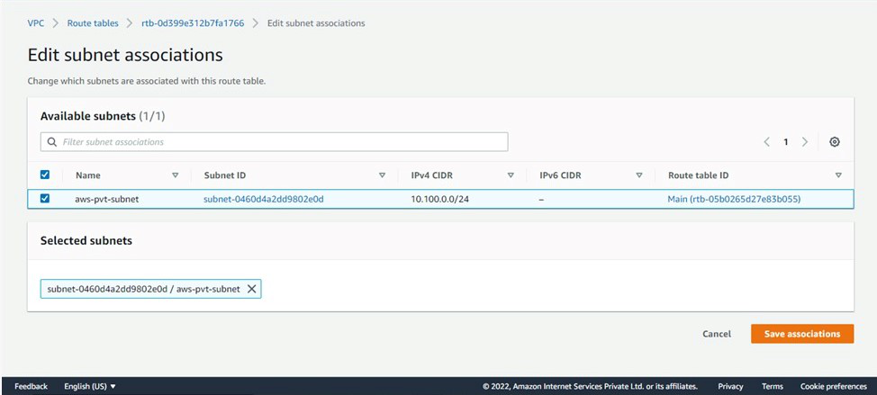

Step 5: Now launch a EC2 instance > Go to EC2 instance > Click on Launch an instance > Fill in the details( Type: t2.micro, Storage: Default, Tags – Name: give a name, Security: Give it according to your requirement, Keypair: your existing key pair or create new if you don’t have an existing keypair > Launch instance. The above steps form the AWS side network
Step 6: Go to other regions (different from the previous one) > Then create a VPC as mentioned in Step-1(Give it CIDR -10.200.0.0/16)
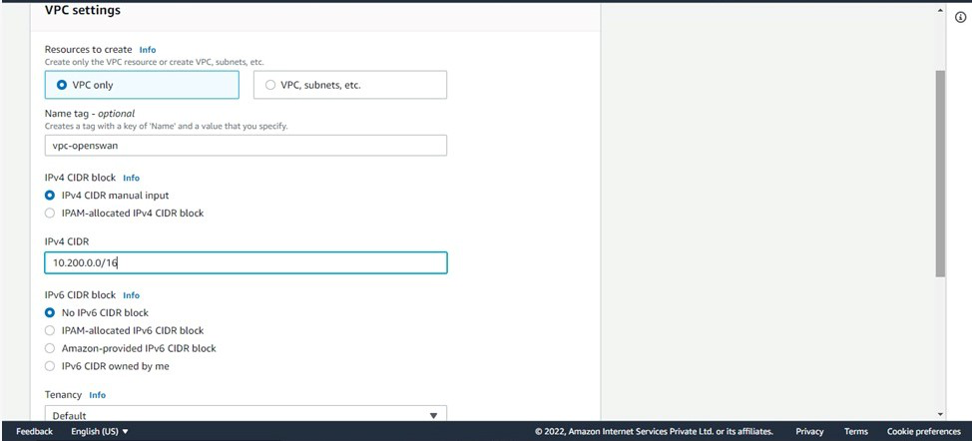

Step 7: Create a Public subnet under it- For that search, subnet > Click on create subnet > Fill in the details (Choose above created VPC, give a Name, Availability zone, CIDR range-10.200.0.0/24) > Click on create a subnet.
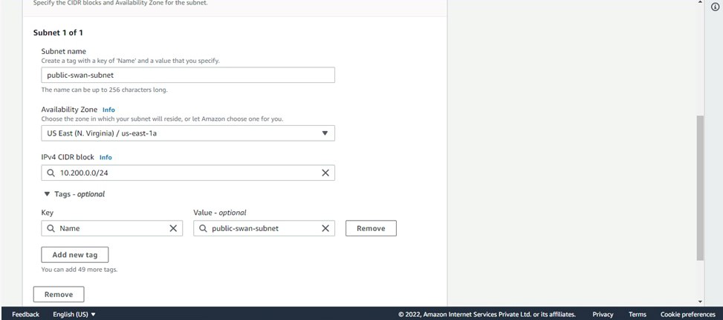

Step 8: Since it is a public subnet it will have access to the internet so we need an Internet gateway.
Go to internet gateway click on create internet gateway > Give it a name and create > click on created gateway(Actions > attach with vpc > give the above created VPC).
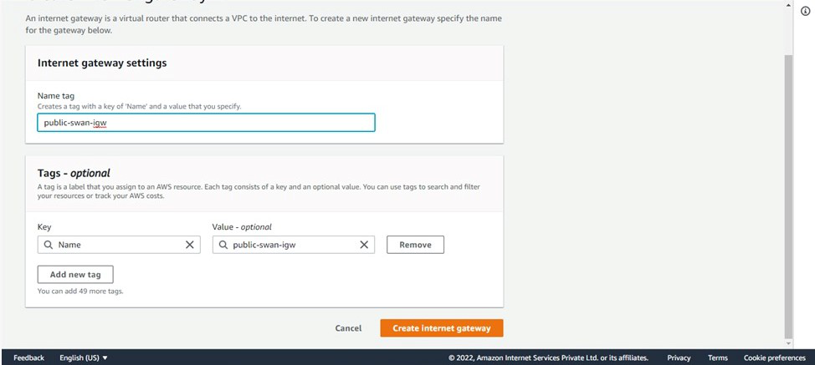

Try to attach the VPC to the Internet Gateway, the following screenshot illustrates with effectively:
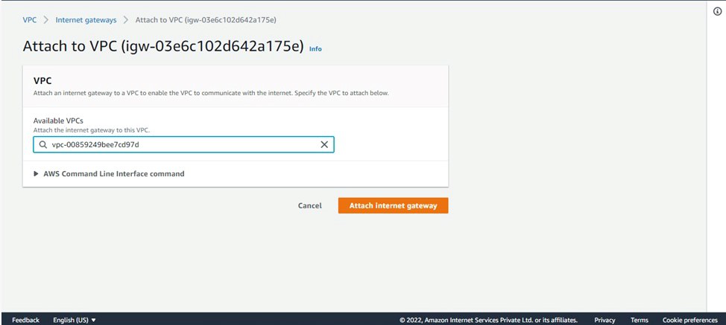

Step 9: Go to route table > Click on create route > Fill in the details(Give it name and choose VPC created on step-6) > Click on create.

Step 10: Add a route entry for Internet gateway- Select Route table > Go to Routes > Click Edit Routes > Add Route(give the internet gateway created) > Save.
Associate route table with the subnet- Select Route table > Subnet Associations > Edit Subnet Associations > Select above created Subnet > Save.
Step 11: Now launch a EC2 instance >Go to EC2 instance > Click on Launch an instance >Fill in the details(Type: t2.micro, Storage: Default, Tags – Name: give a name, Security: Allow port 22 for your own IP and All TCP and ICMP-IPv4 from sources, Keypair: your existing key pair or create new if you don’t have an existing keypair>Launch instance.
Step 12: Now to create Virtual Private Gateway > Search virtual private gateway > Click on create VPG > (Give it a name).
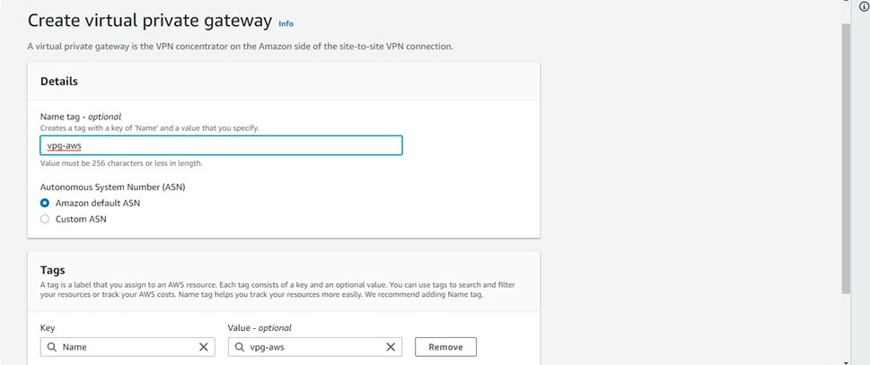

Step 13: Now go to actions > Attach VPC > Choose VPC-aws(VPC with private subnet).

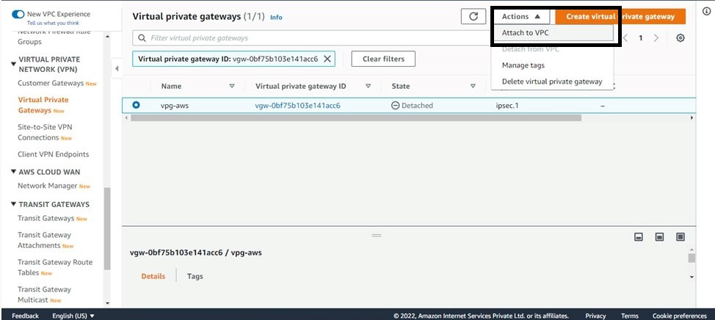

Step 14: Go to route table>Click on edit route propagation>Enable On your Virtual private gateway on all created route tables for both the vpc.
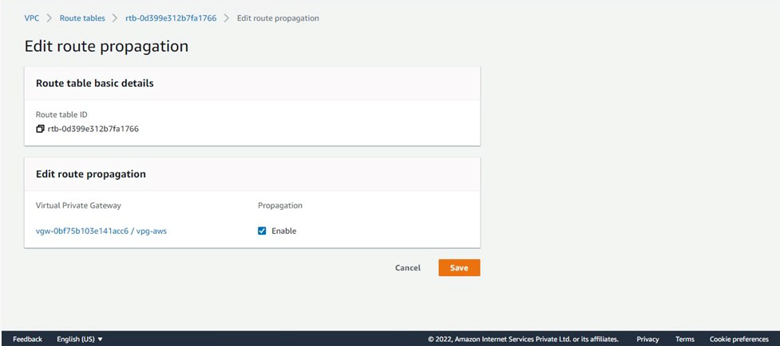

Step 15: Now to create Customer Gateway > Go to Customer Gateway > Click on create CGW > Give name, give IP address as Public IP of Instance you launched with public subnet > Select routing as static-Keep all other things as it is > click on create.

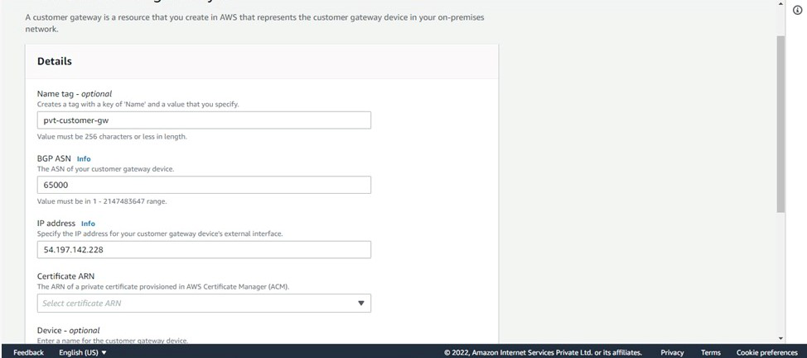

Step 16: To create Site-To-Site connection: Go to site-to-site VPN connections > Click on create VPN(Give a name, Target gateway-Virtual Private gateway(Give the VPG created above), Customer gateway-Existing(Give the CG you created above), Routing option-static) keep all others as it is and creates.
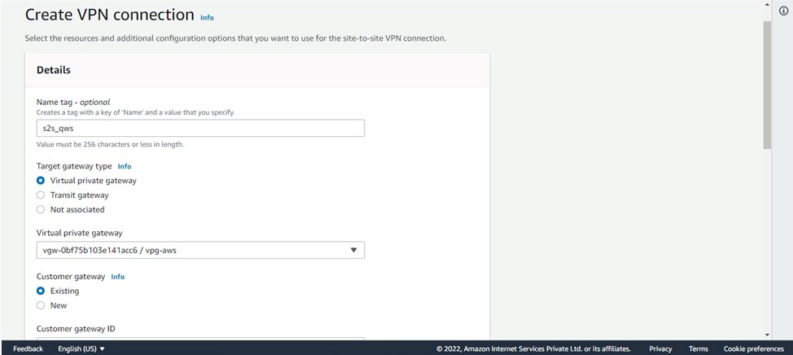

Now, customize the existing gateway:

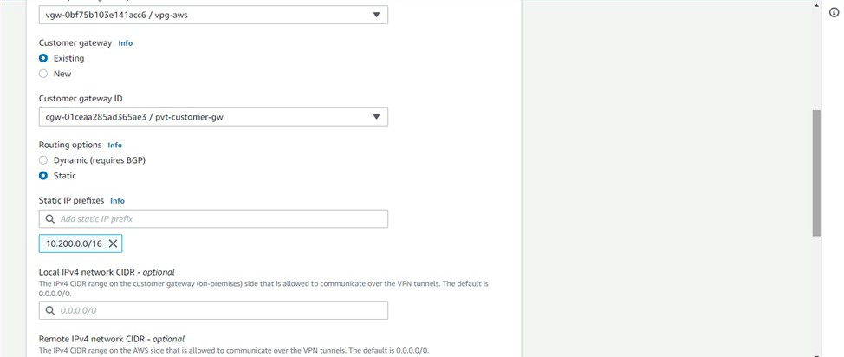

Wait till the state becomes available. After it is available.
Step 17: Download the configuration(select vendor as Openswan).
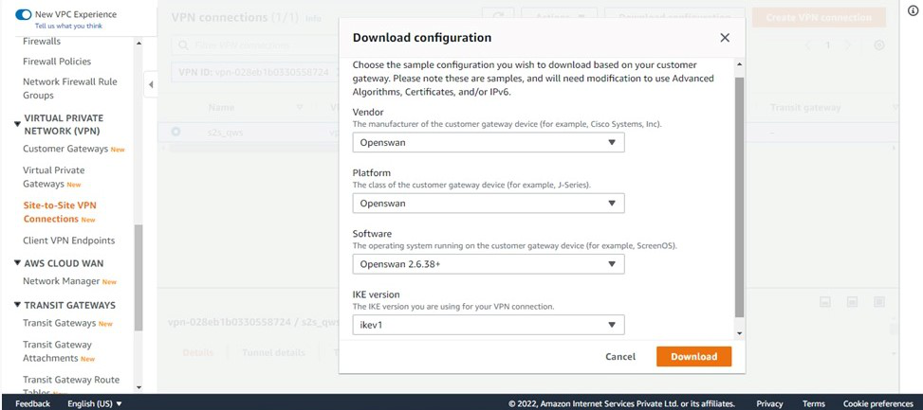

Step 18: Now SSH into your instance created with a public subnet:
Run the following commands:
sudo su

Install openswan: $ yum install openswan –y

Go to- vim /etc/sysctl.conf and update
net.ipv4.ip_forward = 1
net.ipv4.conf.all.accept_redirects = 0
net.ipv4.conf.all.send_redirects = 0

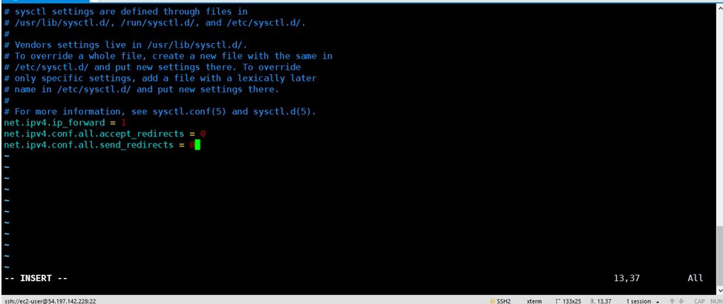

Restart service Network- $ service network restart
Create a file /etc/ipsec.d/aws.conf
Inside that file paste the conn Tunnel1 details from downloaded configuration file.
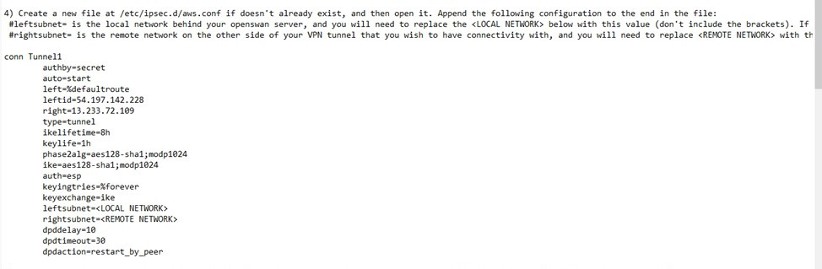
Use Cases of AWS Site-to-Site VPN Connection
- Moving Applications to the Cloud: A Site-to-Site VPN connection helps streamline the migration of applications to AWS. It enables you to securely host Amazon VPCs behind your company's firewall, allowing users to continue accessing these applications without any disruption during the migration process.
- Safe Communication between Remote Offices: You can use AWS Site-to-Site VPN to create secure communication channels between different office locations, ensuring that data is transmitted safely between remote sites.
Troubleshooting of AWS Site-to-Site Connection
- Connection Failures: On ensuring that the VPN endpoints are correctly configured and that the IP addresses are correctly specified on both ends.
- Tunnel Status Down: Ensure to check the status of the VPN tunnels in the AWS Management Console and try to verify that the required ports (UDP 500 and UDP 4500) are open on your firewall.
- Routing Issues: Try to confirm that the routing tables in your VPC and on-premises network with including the appropriate routes to direct traffic through the VPN connection.
- Security Policies: Make ensure that the security policies and encryption settings of match on both the AWS side and the on-premises VPN device to establish a secure connection.
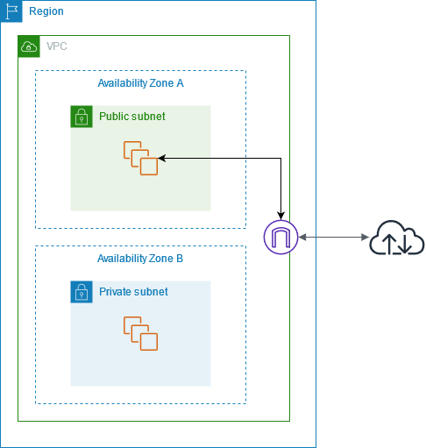

IP ADDRESS AND NAT:
To enable communication over the internet for IPv4, your instance must have a public IPv4 address. You can either configure your VPC to automatically assign public IPv4 addresses to your instances, or you can assign Elastic IP addresses to your instances. Your instance is only aware of the private (internal) IP address space defined within the VPC and subnet. The internet gateway logically provides the one-to-one NAT on behalf of your instance, so that when traffic leaves your VPC subnet and goes to the internet, the reply address field is set to the public IPv4 address or Elastic IP address of your instance, and not its private IP address. Conversely, traffic that's destined for the public IPv4 address or Elastic IP address of your instance has its destination address translated into the instance's private IPv4 address before the traffic is delivered to the VPC.

To enable communication over the internet for IPv6, your VPC and subnet must have an associated IPv6 CIDR block, and your instance must be assigned an IPv6 address from the range of the subnet. IPv6 addresses are globally unique, and therefore public by default.
Internet access for default and nondefault VPCs
The following table provides an overview of whether your VPC automatically comes with the components required for internet access over IPv4 or IPv6.
Component | Default VPC | Nondefault VPC
Internet gateway | Yes | No
Route table with route to internet gateway for IPv4 traffic (0.0.0.0/0) | Yes | No
Route table with route to internet gateway for IPv6 traffic (::/0) | No | No
Public IPv4 address automatically assigned to instance launched into subnet | Yes (default subnet) | No (nondefault subnet)
IPv6 address automatically assigned to instance launched into subnet | No (default subnet) | No (nondefault subnet)

An egress-only internet gateway is a horizontally scaled, redundant, and highly available VPC component that allows outbound communication over IPv6 from instances in your VPC to the internet, and prevents the internet from initiating an IPv6 connection with your instances.
An egress-only internet gateway is for use with IPv6 traffic only. To enable outbound-only internet communication over IPv4, use a NAT gateway instead. For more information, see NAT gateways.
IPv6 addresses are globally unique, and are therefore public by default. If you want your instance to be able to access the internet, but you want to prevent resources on the internet from initiating communication with your instance, you can use an egress-only internet gateway. To do this, create an egress-only internet gateway in your VPC, and then add a route to your route table that points all IPv6 traffic (::/0) or a specific range of IPv6 address to the egress-only internet gateway. IPv6 traffic in the subnet that's associated with the route table is routed to the egress-only internet gateway.

An egress-only internet gateway is stateful: it forwards traffic from the instances in the subnet to the internet or other AWS services, and then sends the response back to the instances.
You can't associate a security group with an egress-only internet gateway to control the traffic that is allowed to reach or leave the egress-only internet gateway. You can use a network ACL to control the traffic to and from the subnet for which the egress-only internet gateway routes traffic.
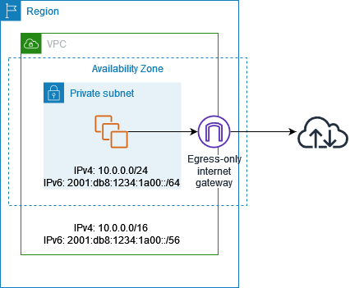

Destination | Target
10.0.0.0/16 | Local
2001:db8:1234:1a00:/64 | Local
::/0 | eigw-id
The following is an example of the route table associated with the subnet. There is a route that sends all internet-bound IPv6 traffic (::/0) to the egress-only internet gateway.

The VPC has public subnets and private subnets in two Availability Zones. Each public subnet contains a NAT gateway and a load balancer node. The servers run in the private subnets, are launched and terminated by using an Auto Scaling group, and receive traffic from the load balancer. The servers can connect to the internet by using the NAT gateway. The servers can connect to Amazon S3 by using a gateway VPC endpoint.
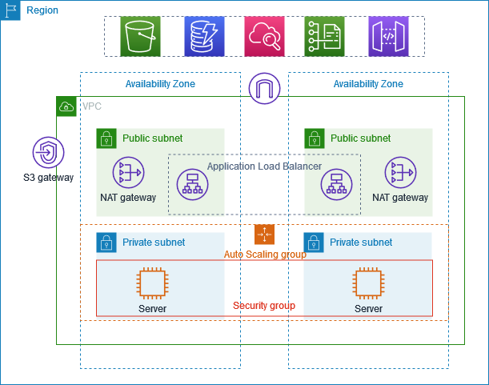

- Routing
When you create this VPC by using the Amazon VPC console, we create a route table for the public subnets with local routes and routes to the internet gateway. We also create a route table for the private subnets with local routes, and routes to the NAT gateway, egress-only internet gateway, and gateway VPC endpoint.

The following is an example of the route table for the public subnets, with routes for both IPv4 and IPv6. If you create IPv4-only subnets
instead of dual stack subnets, your route table includes only the IPv4 routes.
Destination | Target
10.0.0.0/16 | local
2001:db8:1234:1a00::/56 | local
0.0.0.0/0 | igw-id
::/0 | igw-id

route table for one of the private subnets, with routes for both IPv4 and IPv6. If you created IPv4-only subnets, the route table includes only the IPv4 routes. The last route sends traffic destined for Amazon S3 to the gateway VPC endpoint.
Destination | Target
10.0.0.0/16 | local
2001:db8:1234:1a00::/56 | local
0.0.0.0/0 | nat-gateway-id
::/0 | eigw-id
s3-prefix-list-id | s3-gateway-id

Security

The security group must allow traffic from the load balancer over the listener port and protocol. It must also allow health check traffic.

Source | Protocol | Comments
ID of the load balancer security group | listener protocol | Allows inbound traffic from the load balancer on the listener port
ID of the load balancer security group | health check protocol | Allows inbound health check traffic from the load balancer

- Create the VPC

- Open the Amazon VPC console at https://console.aws.amazon.com/vpc/.

- On the dashboard, choose Create VPC.

- For Resources to create, choose VPC and more.

- Configure the VPC
- For Name tag auto-generation, enter a name for the VPC.

- For IPv4 CIDR block, you can keep the default suggestion, or alternatively you can enter the CIDR block required by your application or network.

- If your application communicates by using IPv6 addresses, choose IPv6 CIDR block, Amazon-provided IPv6 CIDR block.

- Configure the subnets

- For Number of Availability Zones, choose 2, so that you can launch instances in multiple Availability Zones to improve resiliency.

- For Number of public subnets, choose 2.

- For Number of private subnets, choose 2.

- You can keep the default CIDR block for the public subnet, or alternatively you can expand Customize subnet CIDR blocks and enter a CIDR block. For more information, see Subnet CIDR blocks.

- For NAT gateways, choose 1 per AZ to improve resiliency.

- If your application communicates by using IPv6 addresses, for Egress only internet gateway, choose Yes.

- For VPC endpoints, if your instances must access an S3 bucket, keep the S3 Gateway default. Otherwise, instances in your private subnet can't access Amazon S3. There is no cost for this option, so you can keep the default if you might use an S3 bucket in the future. If you choose None, you can always add a gateway VPC endpoint later on.

- For DNS options, clear Enable DNS hostnames.
- Choose Create VPC.

2. Deploy your application
To launch instances by using an Auto Scaling group
Create a launch template to specify the configuration information needed to launch your EC2 instances by using Amazon EC2 Auto Scaling. For step-by-step directions, see Create a launch template for your Auto Scaling group in the Amazon EC2 Auto Scaling User Guide.
- Create an Auto Scaling group, which is a collection of EC2 instances with a minimum, maximum, and desired size. For step-by-step directions, see Create an Auto Scaling group using a launch template in the Amazon EC2 Auto Scaling User Guide.

- Create a load balancer, which distributes traffic evenly across the instances in your Auto Scaling group, and attach the load balancer to your Auto Scaling group. For more information, see the Elastic Load Balancing User Guide and Use ELB in the Amazon EC2 Auto Scaling User Guide.
3. Test your configuration
After you've finished deploying your application, you can test it. If your application can't send or receive the traffic that you expect, you can use Reachability Analyzer to help you troubleshoot. For example, Reachability Analyzer can identify configuration issues with your route tables or security groups. For more information, see the Reachability Analyzer Guide.
4. Clean up
When you are finished with this configuration, you can delete it. Before you can delete the VPC, you must delete the Auto Scaling group, terminate your instances, delete the NAT gateways, and delete the load balancer. For more information, see Delete your VPC.
Amazon EC2 provides scalable computing capacity in the AWS Cloud. You can launch an EC2 virtual computing environment (an instance) using a preconfigured template (an Amazon Machine Image or AMI). When you launch an EC2 instance, EC2 automatically installs the operating system (Linux or Microsoft Windows) and additional software included in the AMI, such as web server or database software.

You can route traffic for your domain, such as example.com, to your server by using Amazon Route 53, if you're hosting a website or running a web application on an EC2 instance.
Configure a New or Existing VPC with a Public Subnet
Step 1: Configure a VPC with a Public Subnet
Create a New VPC with a Single Public Subnet
When you use the VPC wizard to create a new VPC, the wizard creates an internet gateway and a custom route table that is associated with the public subnet. The route table routes all traffic destined for an address outside the VPC to the internet gateway. For more information about this configuration, see VPC with a Single Public Subnet in the Amazon VPC User Guide.
Complete the steps in Step 1: Create the VPC in the Amazon VPC User Guide to create your VPC.
To enable your fleet instances and image builders to access the internet, complete the steps in Step 2: Enable Default Internet Access Your Fleet, Image Builder, or App Block Builder.
Configure an Existing VPC
If you want to use an existing VPC that does not have a public subnet, you can add a new public subnet. In addition to a public subnet, you must also have an internet gateway attached to your VPC and a route table that routes all traffic destined for an address outside the VPC to the internet gateway. To configure these components, complete the following steps.
To add a public subnet, complete the steps in Creating a Subnet in Your VPC. Use the existing VPC that you plan to use with WorkSpaces Applications.

If your VPC is configured to support IPv6 addressing, the IPv6 CIDR block list displays. Select Don't assign Ipv6.
To create and attach an internet gateway to your VPC, complete the steps in Creating and Attaching an Internet Gateway.
To configure your subnet to route internet traffic through the internet gateway, complete the steps in Creating a Custom Route Table. In step 5, for Destination, use IPv4 format (0.0.0.0/0).
To enable your fleet instances and image builders to access the internet, complete the steps in Step 2: Enable Default Internet Access Your Fleet, Image Builder, or App Block Builder.

Step 2: Enable Default Internet Access Your Fleet, Image Builder, or App Block Builder
After you configure a VPC that has a public subnet, you can enable the Default Internet Access option for your fleet and image builder.

Enable Default Internet Access for a Fleet
To enable internet access at fleet creation
- Complete the steps in Create a Fleet in Amazon WorkSpaces Applications up to Step 4: Configure Network
- Select the Default Internet Access check box.
- If the subnet fields are empty, select a subnet for Subnet 1 and, optionally, Subnet 2.
- Continue with the steps in Create a Fleet in Amazon WorkSpaces Applications.

